North Platte Junior High
Monday, May 9, 2022

Tomorrow night is the JH spring concert. It is at 6:30- be here by 6!

There will be a meeting tomorrow during homeroom for any 6th or 7th grade girl interested in playing basketball next year.

Twisted tators food truck is coming to our school May 16th!
Be sure to bring your money if you want to purchase from them that afternoon.
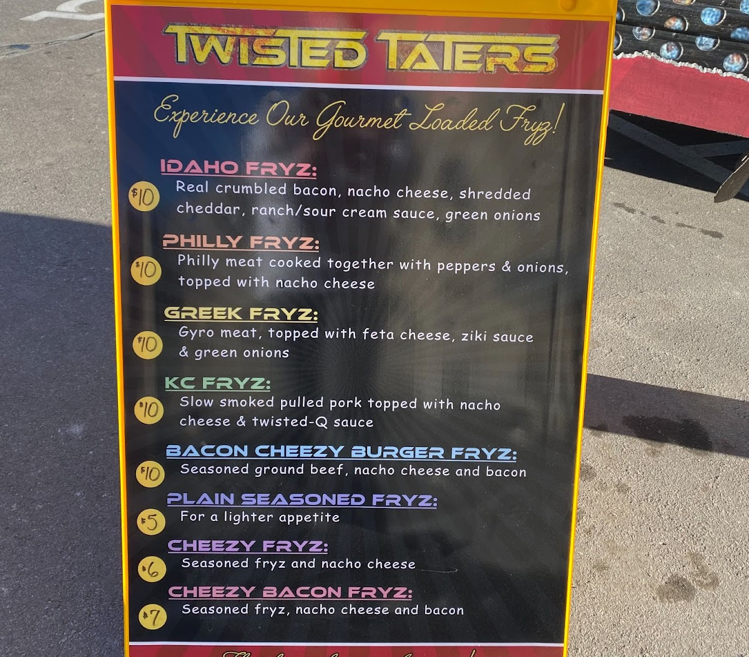

The Junior High FFA meeting originally scheduled for May 3rd has been rescheduled for Wednesday, May 11th from 3:15-4:30pm.

There is information on the office counter about a volleyball camp for anyone going into grades 1st-8th in June. Come get a form if you are interested.

Yearbooks are for sale! $25 each. Order forms are in the office.

JH students- you are NOT ALLOWED to use the vending machines at all. Not before, after, or during school. The vending machines are for High school students only!

There is information in the JH office about summer school. If you are interested in attending be sure to pick one up.

Looking Ahead
May 9th- Map Reward afternoon at the park
May 10th – JH girls bball meeting during homeroom, JH Spring concert 6:30pm
May 11th – JH FFA meeting
May 12th – take everything out of your lockers and take it home!!!
May 13th- WOF field trip
May 16th – fun day! Twisted Taters will be here
May 18th- last day of school dismiss at 12:30. JH awards will be held at 11:10

